
Luxé Cannon 300Z IP RGBAL
300w Ellipsoidal with Motorized Zoom and Shutters
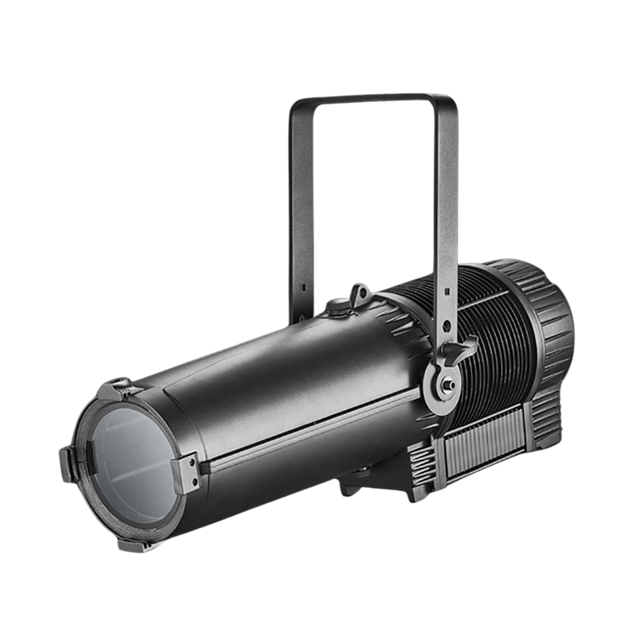

User Manual
Table of Contents
1. Introduction and Setup 3
Unpacking 3
In the Box: 3
Mounting and Operation 3
Safety Precautions 3
Customer Support 5
2. Setup and Operation 6
Using the LCD Menu and Buttons 6
Menu Operation 6
DMX Setup 8
DMX Basics 8
DMX Wiring 8
DMX Modes and Configuration 9
3. Maintenance 17
Troubleshooting Problems 17
4. Technical Specifications 18
5. Photometrics: 19

1. Introduction and Setup

Unpacking
After receiving the device, please check whether any visible damage was caused during transport. lf the power cord, housing or the light are damaged, do not operate the device. Contact your dealer or GAMMA LED Vision immediately.
Thank you for choosing our Luxé Cannon 300Z IP RGBAL. This light is designed by high strength die-casting aluminum which is able to endure high temperatures, and is designed in a stylish form.

It uses high power Red, Green, Blue, Amber, and Lime LED’s for, low power consumption, high brightness, and excellent colors. The Luxé Cannon 300Z IP RGBAL features DMX512 control, standalone, and sound-active modes.

For your own safety, please read this manual before installing or using the device. This manual covers the important information on installation and applications. Please install and operate the fixture with following instructions. Meanwhile, please keep this manual for future needs.

In the Box:
Luxé Cannon 300Z IP RGBAL - 1 pc
PowerCon Power Cable - 1 pc
DMX Cable 3 Pin - 1 pc

Mounting and Operation
Use a clamp rated for the full weight of the Luxé Cannon 300Z IP RGBAL to hang the fixture from the mount(s) on the fixture’s yoke.
As an added safety measure be sure to attached at least one properly rated safety cable to the fixture using on of the safety cable rigging point integrated in the base assembly or on the yoke.

Safety Precautions
Caution: For added protection mount the fixtures in areas outside walking paths, seating areas, or in areas were the fixture might be reached by unauthorized personnel.
Before mounting the fixture to any surface, make sure that the installation area can hold a minimum point load of 10 items the device’s weight.
Fixture installation must always be secured with a secondary safety attachment, such as an appropriate safety cable.
Never stand directly below the device when mounting, removing, or servicing the fixture.
From a ceiling, or set on a flat level surface (see illustration below). Be sure this fixture is kept at least 0.5m (1.5ft) away from any flammable materials (decoration etc.).
Always use and install the supplied safety cable as a safety measure to prevent accidental damage and/or injury in the event the clamp fails.
∙Don’t try to modify the fixture without any instruction by the manufacturer or the appointed repairing agencies.
∙Warranty is voided if there are any malfunctions from not following the user manual while operating or any hazardous operation, like shock short circuit, electronic shock, lamp broken, etc.

Allow the Luxé Cannon 300Z IP RGBAL LED to cool for at least 15 minutes before handling after use.

Customer Support
WARRANTY POLICY
GAMMA LED Vision warrants its products for the periods set below from the date of purchase to be free of manufacturer and workmanship defects. Warranty does not cover normal wear and tear caused by force, negligence or misuse of products. GAMMA LED Vision is not responsible for any damages or injury caused by misuse or improper handling of the products and in accordance with instructions and specifications of manual.
Warranty terms are as follows:
LED Fixtures:
Indoor: 2 Years
Outdoor (IP 54 or higher): 1 Year
Lamp Fixtures: 1 year / excludes the lamp
LED Video Products:
Indoor: 2 Years
Outdoor (IP 54 or higher): 1 Year
Controllers: 2 years
Batteries: 6 months
All Trussing Related Products and Accessories: 1 Year
Please visit WWW.GAMMALEDVISON.COM for complete Limited Warranty terms and contact information.

2. Setup and Operation

Using the LCD Menu and Buttons
The menu is accessible via the touchscreen interface. If presented with a lockscreen, the password is +, -, +, -, Enter. (Plus, Minus, Plus, Minus, Enter)

Menu Operation
Use the Menu Key to enter the menu. The chart below shows the main options and explains the settings. Always press “Enter” to confirm any settings changed.

Main Menu Option | Sub-Menu Option | Value | Function
DMX | DMX Address | 001-512 | Set the DMX Address
DMX | DMX Profile | 05CH, 24CH | Set the channel mode
DMX | Motor Control | Value/Channel | Set the values manually for each channel via the menu.
Master | Mixed Color | Set each channel manually | Manual mode – set each color manually from 0-255
Master | Auto Mode |  | Auto mode – select the program and speed as desired.
Master | Sound Mode |  | Sound-active mode
Master | White Point |  | Set manually by color temperature
Master | Quick Color |  | Set manually by gel color
Master | Motor Control |  | Manually adjust internal motors.
Status |  |  | See a variety of status indicators and measurements.
Settings | White Point Edit |  | ***Use only with password from GAMMA LED Vision**
Settings | Reset Calibration |  | Adjust the motor calibration for each internal motor.
Settings | Dimmer Frequency |  | Set the PWM Frequency of the LED Dimmer
Settings | Dimmer Curve |  | Choose the Dimmer Curve
Settings | Over Temperature |  | Set the Overtemperature shutdown value – Do not change this setting unless directed by GAMMA LED Vision.
Settings | Backlight |  | Set the backlight brightness for the menu LCD.
Settings | Backlight Timeout |  | Set the timeout for the factory LCD
Settings | Load Factory Settings |  | Factory reset of all settings.

DMX Setup

DMX Basics
DMX512 stands for digital multiplex 512. This means that 512 channels are controlled digitally through 1 data cable.
A channel is a set of 255 steps that are assigned to control attributes in each light. This may be a color like red, green or blue, and intensity, strobe, pan/tilt or other attributes.
Multiple sets of 512 “universes” may be used. Only 1 universe will travel on a DMX cable, but through networked DMX (Art-Net or sACN E1.31), many universes can travel over a network.

DMX Wiring
DMX works by connecting 1 or multiple lights to the output of a DMX lighting console or software with a DMX interface.
DMX lights connect in what is called a “daisy-chain”. Your first DMX cable will plug it’s male DMX connector into the female DMX connector on your lighting console. The remaining female connector will then connect to the DMX input on your first light.
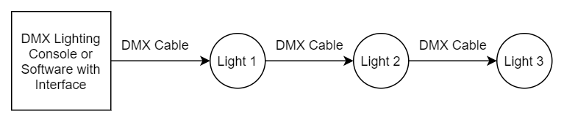
You may then connect your next fixture to the output of your first light, and continue the chain.
32 Fixture Rule – DMX only allows you to connect up to 32 fixtures in a single daisy chain for signal strength. Sometimes, depending on the fixtures and cable length, this number is less (or more).
DMX Cables can be 3-pin or 5-pin. These use the same type of data, and in the 5-pin only pins 1, 2, and 3 are used. The cable should be a 2 conductor, shielded cable of at least 110 ohms resistance. Microphone cable is not DMX cable.
Please refer to the diagram below:
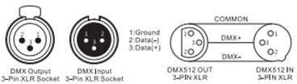
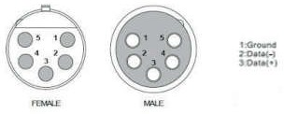
For installations where the DMX cable has to run a long distance or is in an electrically noisy environment, it is recommended to use a DMX terminator. This helps in preventing corruption of the digital control signal by electrical noise and reflections. The DMX terminator is simply an XLR plug with a 120 Ω resistor connected between pins 2 and 3, which is then plugged into the output XLR socket of the last fixture in the chain. Please see illustrations below:

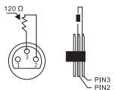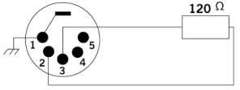

DMX Modes and Configuration
The Luxé Cannon 300Z IP RGBAL has multiple DMX modes, sometimes called “personalities”, “profiles”, or as we will use here “modes”.
In general, modes with more DMX channels offer a greater level of control or options but take up more of your output channels on your lighting console or software.
Modes with less DMX channels often offer less control, but may be plenty for your needs. Depending on your needs and control solution, you may not need channels for automated programs, strobes, or macros – your console may have great effects! In this case, you can use a lesser channel mode and fit more lights per DMX universe.
View the DMX mode charts below to find the mode that best suits your needs.
DMX Channel Mode Sheet:
On the left side of the sheet you will see the different modes and which channel corresponds to each function listed on the right in the given mode.
Luxe Cannon 300 RGBAL
GAMMA LED Vision – DMX Chart

STD Mode (24 Ch) | Basic Mode (5 CH) | Function | Values | Description
1 |  | Dimmer | 0-255 | Master Intensity Control
2 | 1 | Red | 0-255 | Red Control
3 | 2 | Green | 0-255 | Green Control
4 | 3 | Blue | 0-255 | Blue Control
5 | 4 | Amber | 0-255 | Amber Control
6 | 5 | Lime | 0-255 | Lime Control
7 |  | CTC | 0-9 | No Function
7 |  | CTC | 10-19 | Color Temperature Preset 1
7 |  | CTC | 20-29 | Color Temperature Preset 2
7 |  | CTC | 30-39 | Color Temperature Preset 3
7 |  | CTC | 40-49 | Color Temperature Preset 4
7 |  | CTC | 50-59 | Color Temperature Preset 5
7 |  | CTC | 60-69 | Color Temperature Preset 6
7 |  | CTC | 70-79 | Color Temperature Preset 7
7 |  | CTC | 80-89 | Color Temperature Preset 8
7 |  | CTC | 90-99 | Color Temperature Preset 9
7 |  | CTC | 100-109 | Color Temperature Preset 10
7 |  | CTC | 110-119 | Color Temperature Preset 11
7 |  | CTC | 120-129 | Color Temperature Preset 12
7 |  | CTC | 130-139 | Color Temperature Preset 13
7 |  | CTC | 140-149 | Color Temperature Preset 14
7 |  | CTC | 150-159 | Color Temperature Preset 15
7 |  | CTC | 160-169 | Color Temperature Preset 16
7 |  | CTC | 170-179 | Color Temperature Preset 17
7 |  | CTC | 180-189 | Color Temperature Preset 18
7 |  | CTC | 190-199 | Color Temperature Preset 19
7 |  | CTC | 200-209 | Color Temperature Preset 20
7 |  | CTC | 210-219 | Color Temperature Preset 21
7 |  | CTC | 220-229 | Color Temperature Preset 22
7 |  | CTC | 230-239 | Color Temperature Preset 23
7 |  | CTC | 240-249 | Color Temperature Preset 24
7 |  | CTC | 250-255 | No Function
8 |  | Color Macros | 0-9 | No Function
8 |  | Color Macros | 10-19 | Color Macro Preset 1
8 |  | Color Macros | 20-29 | Color Macro Preset 2
8 |  | Color Macros | 30-39 | Color Macro Preset 3
8 |  | Color Macros | 40-49 | Color Macro Preset 4
8 |  | Color Macros | 50-59 | Color Macro Preset 5
8 |  | Color Macros | 60-69 | Color Macro Preset 6
8 |  | Color Macros | 70-79 | Color Macro Preset 7
8 |  | Color Macros | 80-89 | Color Macro Preset 8
8 |  | Color Macros | 90-99 | Color Macro Preset 9
8 |  | Color Macros | 100-109 | Color Macro Preset 10
8 |  | Color Macros | 110-119 | Color Macro Preset 11
8 |  | Color Macros | 120-129 | Color Macro Preset 12
8 |  | Color Macros | 130-139 | Color Macro Preset 13
8 |  | Color Macros | 140-149 | Color Macro Preset 14
8 |  | Color Macros | 150-159 | Color Macro Preset 15
8 |  | Color Macros | 160-169 | Color Macro Preset 16
8 |  | Color Macros | 170-179 | Color Macro Preset 17
8 |  | Color Macros | 180-189 | Color Macro Preset 18
8 |  | Color Macros | 190-199 | Color Macro Preset 19
8 |  | Color Macros | 200-209 | Color Macro Preset 20
8 |  | Color Macros | 210-219 | Color Macro Preset 21
8 |  | Color Macros | 220-229 | Color Macro Preset 22
8 |  | Color Macros | 230-239 | Color Macro Preset 23
8 |  | Color Macros | 240-249 | Color Macro Preset 24
8 |  | Color Macros | 250-255 | No Function
9 |  | Strobe | 0-10 | No Function
9 |  | Strobe | 11-255 | Strobe, Slow to Fast (1-25 Hz)
10 |  | Auto Programs | 0-9 | No Function
10 |  | Auto Programs | 10-19 | Auto Run Preset 1
10 |  | Auto Programs | 20-29 | Auto Run Preset 2
10 |  | Auto Programs | 30-39 | Auto Run Preset 3
10 |  | Auto Programs | 40-49 | Auto Run Preset 4
10 |  | Auto Programs | 50-59 | Auto Run Preset 5
10 |  | Auto Programs | 60-69 | Auto Run Preset 6
10 |  | Auto Programs | 70-79 | Auto Run Preset 7
10 |  | Auto Programs | 80-89 | Auto Run Preset 8
10 |  | Auto Programs | 90-99 | Auto Run Preset 9
10 |  | Auto Programs | 100-109 | Auto Run Preset 10
10 |  | Auto Programs | 110-119 | Auto Run Preset 11
10 |  | Auto Programs | 120-129 | Auto Run Preset 12
10 |  | Auto Programs | 130-139 | Auto Run Preset 13
10 |  | Auto Programs | 140-149 | Auto Run Preset 14
10 |  | Auto Programs | 150-159 | Auto Run Preset 15
10 |  | Auto Programs | 160-169 | Auto Run Preset 16
10 |  | Auto Programs | 170-179 | Auto Run Preset 17
10 |  | Auto Programs | 180-189 | Auto Run Preset 18
10 |  | Auto Programs | 190-199 | Auto Run Preset 19
10 |  | Auto Programs | 200-209 | Auto Run Preset 20
10 |  | Auto Programs | 210-219 | Auto Run Preset 21
10 |  | Auto Programs | 220-229 | Auto Run Preset 22
10 |  | Auto Programs | 230-239 | Auto Run Preset 23
10 |  | Auto Programs | 240-249 | Auto Run Preset 24
10 |  | Auto Programs | 250-255 | No Function
11 |  | Framing Shutter 1 Position | 0-255 | Inserts Framing Shutter 1
12 |  | Framing Shutter 1 Angle | 0-255 | Angle Adjustment of Framing Shutter 1
13 |  | Framing Shutter 2 Position | 0-255 | Inserts Framing Shutter 2
14 |  | Framing Shutter 2 Angle | 0-255 | Angle Adjustment of Framing Shutter 2
15 |  | Framing Shutter 3 Position | 0-255 | Inserts Framing Shutter 3
16 |  | Framing Shutter 33 Angle | 0-255 | Angle Adjustment of Framing Shutter 3
17 |  | Framing Shutter 4 Position | 0-255 | Inserts Framing Shutter 4
18 |  | Framing Shutter 4 Angle | 0-255 | Angle Adjustment of Framing Shutter 4
19 |  | Zoom | 0-255 | Zoom 30° to 15°
20 |  | Focus | 0-255 | Focus Control
21 |  | Gobo Control | 0-255 | Optional Gobo Control Accessory
22 |  | Iris Control | 0-255 | Optional Iris Control Accessory
23 |  | Framing Macros | 0-63 | No Function
23 |  | Framing Macros | 64-255 | Framing Macros
24 |  | Control | 0-249 | No Function
24 |  | Control | 250-255 | Reset All Motors

3. Maintenance

Troubleshooting Problems
The following are a few common problems that may occur during operation. Here are some suggestions for easy troubleshooting:
A. The unit does not work:
- Check that the unit is plugged in to a working power connector.
- Press the menu button to confirm that the unit is powered on. If the screen does not light up, the unit has no power.
B. Not Responding to the DMX Controller
- Check DMX cables to verify that they are plugged in and functional.
- Check the DMX address and mode – does it match the address and mode patched in the lighting console or software?
- Plug the light directly into the DMX controller with a cable that you know is good. Unplug all other lights – does it work?
- Try to use another DMX controller.

4. Technical Specifications
- Rated voltage: 100V-240VAC, 50/60Hz
- Power Consumption:300w Max
- LEDs: 300w RGBAL
- Lamp rated life: >50000 Hours
- Beam angle: 15-30 degree
- Strobe: Independent electronic strobe, 0-20 hz, the speed can be adjusted
- Control Mode: DMX512 control, Auto Run, Master/Slave, Sound-Active
- IP Rating: IP 65
- Net Weight: 44lbs
- Certification: CE, RoHS
- RDM UID: 1901:82B2DC04

5. Photometrics:
4300k (High CRI Mix)
CRI: 85.7 CRI
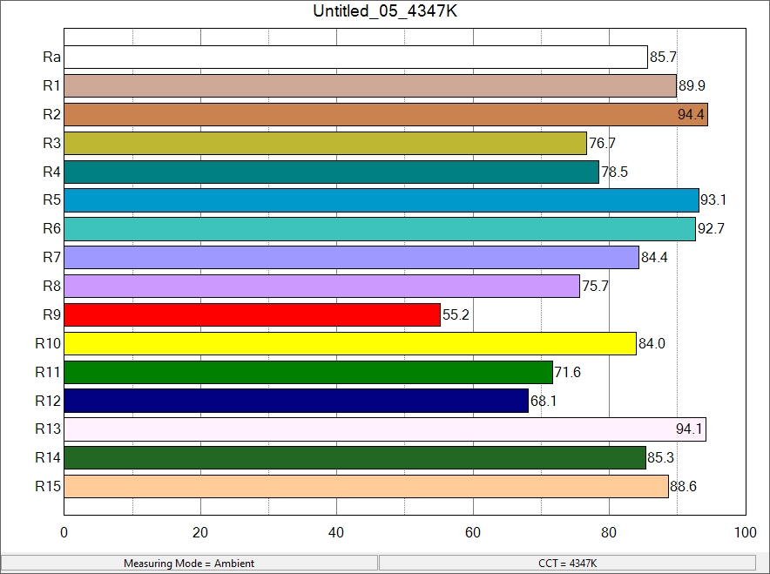
TM30
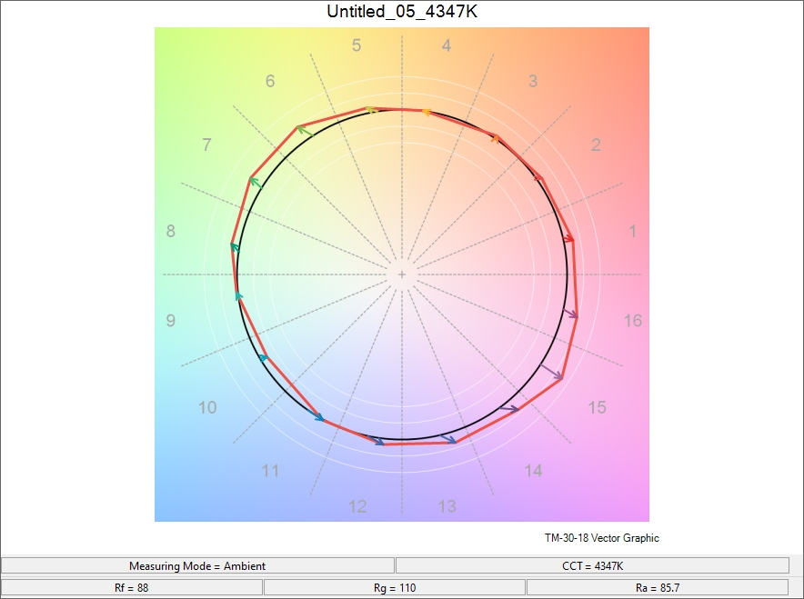
Illuminance Report:
 | At Full – 15 Degree | At Full 30 Degree | High CRI Mix – 4300k, 85.7 CRI – 15 Degree
5’ | 2930 fc | 1040 fc | 2450 fc
10’ | 927 fc | 298 fc | 885 fc
15’ | 451 fc | 143 fc | 435 fc
20’ | 252 fc | 78 fc | 235 fc
30’ | 104 fc | 33 fc | 98 fc
35’ | 85 fc | 26 fc | 79 fc

